DQA on Elekta

# Purpose

This procedure details the steps involved in performing delivery quality assurance (DQA) plan on Elekta.

For DQA troubleshooting tips, see [DQA Troubleshooting](DQA%20Troubleshooting.docx) in T:\Physics\QA & Procedures\DQA.

# Steps

1. Prep the DQA plan.
   1. Open the plan in RayStation. It is best practice not to prep QA on a plan until the MD has approved it. Unlike Tomo, though, RayStation does allow DQA prep on unapproved plans.

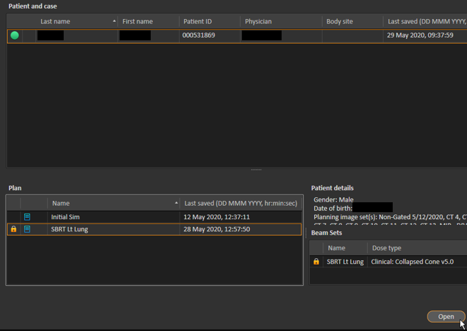

* 1. Create the QA plan.
     1. Navigate to the **QA Preparation** tab.

C:\Users\jm84u\Pictures\qaprep.png

* + 1. Run the script **Create QA Plan**.

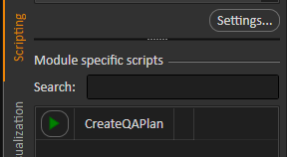

If the script does not work, perform the steps manually:

* + - 1. Click **New QA Plan**.

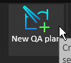

* + - 1. Name the DQA plan <plan name> DQA. There is a 16-character limit for plan names, so if the DQA suffix makes the plan name too long, truncate it (e.g., SBRT Right Lung DQA → SBRT Right L DQA, or maybe SBRT Rt Lung DQA makes more sense ☺️).

Use the following settings. The dose grid should be the same size as the plan dose grid.

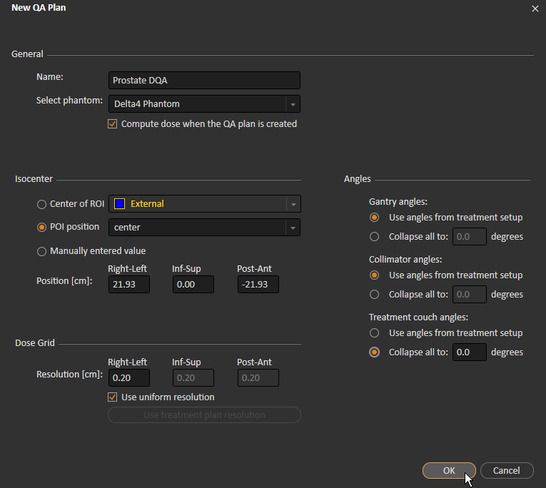

* + - 1. Ensure that the electronics on the phantom will not be excessively irradiated. Zach’s rule of thumb is that electronics can withstand 20 cGy per fraction. Add a 20 cGy isodose line.
      2. Under **QA Preparation**, double-click the colors key.



* + - 1. Click **Add level**. Change the **Level** to 20 cGy. Change the color so it is distinct from the other colors. Click **OK**.

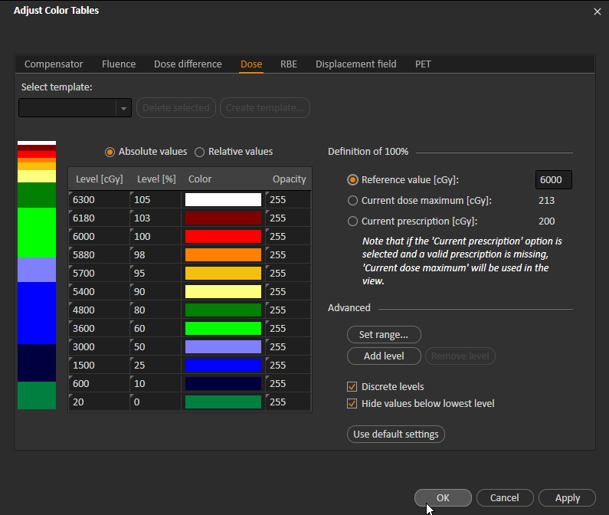

* + - 1. Examine the Coronal view of the phantom to ensure that the new isodose line does not extend beyond ~22.5 cm inferior to the origin. The electronics are about 22.5 cm from the phantom center.

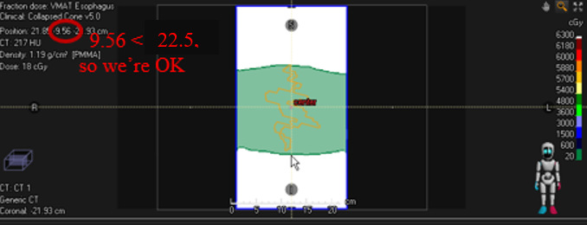

* + - 1. Export the DQA plan.
         1. Click **Export QA Plan**.

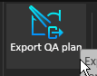

* + - * 1. Select the browse button next to **DICOM media file**.

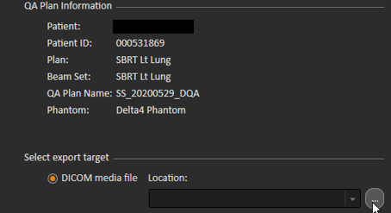

* + - * 1. Navigate to T:\Physics\QA & Procedures\Delta4\DQA Plans and create a new folder called <last name>, <first name> <plan name> DQA. Create a subfolder for each Radiation Device for which the plan will be measured in Delta4. Currently, we use ELEKTA for E1, and E2 for E2.

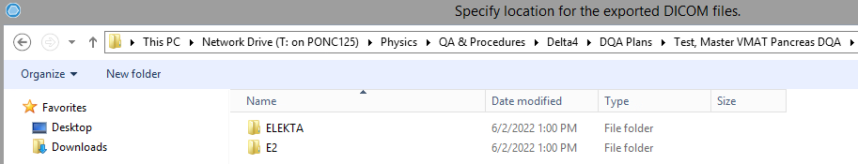

Export the DICOM to one of these folders. ELEKTA is the machine used in the RayStation plan, so I’ll export to the ELEKTA folder for simplicity.

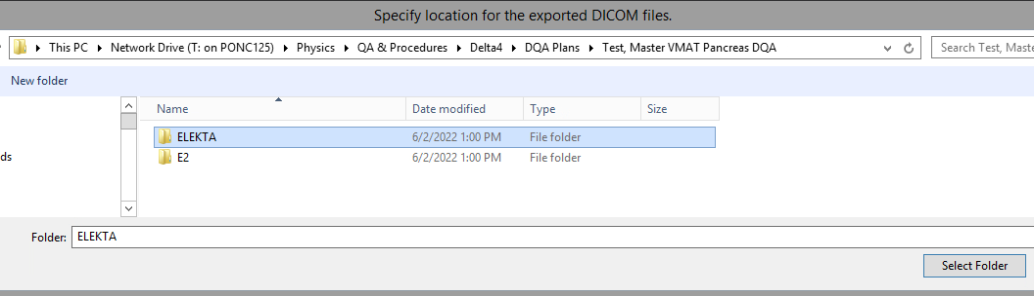

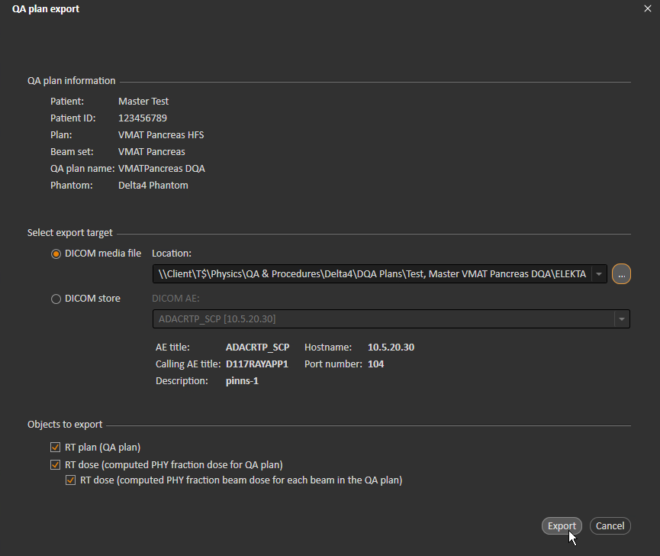

* + - * 1. Copy the files into each other Radiation Device folder. For each Radiation Device, open the RTPLAN file (filename starts with RP) in Dicom Editor. For each item in the (300A, 00B0) Beam Sequence attribute, change the (300A, 00B2) Treatment Machine Name and (4001, 1012) Private Data attributes to the new Radiation Device.

To change an attribute value, double-click the attribute and enter the correct value in the dialog box, and click **Okay**.

Editing (300A, 00B2):

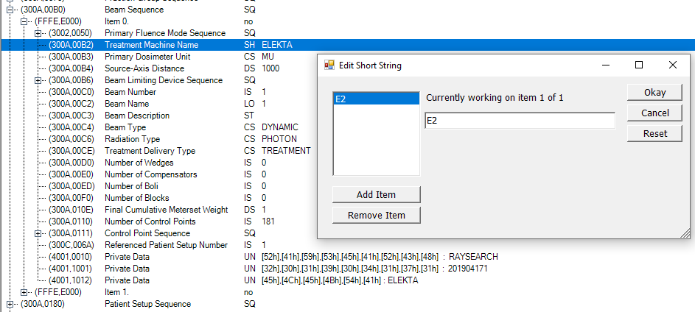

Editing (4001, 1012):

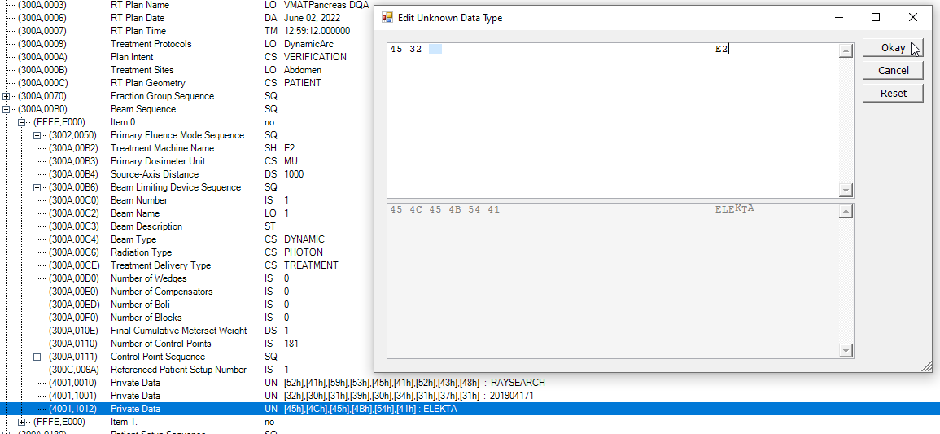

Overwrite the original RTPLAN file with your changes.

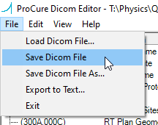

The default settings are fine:

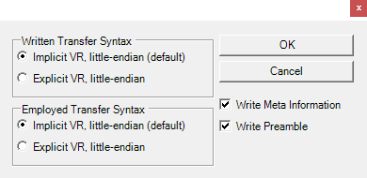

Select the original file in File Explorer to populate the correct name in the File name field.

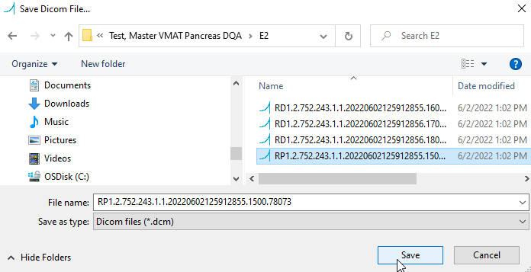

Confirm that you want to overwrite the original file.

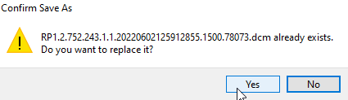

1. Double-check MOSAIQ for machine and beams.
   1. Open the patient in MOSAIQ.
      1. Go to **File** > **Schedule** to see which machine the patient is scheduled on.
      2. Go to **RO Treat**.

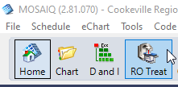

* + 1. There should be fields scheduled. If there are not, print the patient to MOSAIQ before shooting their QA. See [RayStation Plans to MOSAIQ](../RayStation%20Plans%20to%20MOSAIQ.docx) in T:\Physics\MOSAIQ for information on printing to MOSAIQ. If the machine does not match the machine for which the patient is scheduled, inform dosimetry.

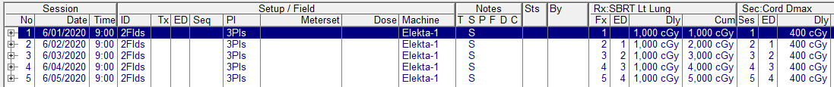

1. Set up the Delta4 computer.
   1. Close the Delta4 software if it open. Often, the phantom cannot connect to the software if the software is open before the phantom is turned on.
   2. Ensure that E1 or E2 (whichever the patient will be treated on) is free at the time that you want to shoot QA. You can check **RO Treatment** in MOSAIQ.
   3. Unplug all cables (e.g., network, power, scanner) from the Delta4 computer. Do not unplug the network-to-USB adapter. Take the Delta4 computer to the E1/E2 console and plug in the network and phantom cables. For E1, both cables are behind the SunCheck computer at the E1 console. For E2, the phantom cable is behind the SunCheck computer, and the network cable is under the counter. Plug the E2 network cable directly into the wall.
2. Bring up the patient.
   1. Log in to MOSAIQ on the middle computer and open the patient.
   2. Click **RO Treat**.
   3. Click **QA Mode**.

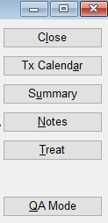

* 1. Click **Yes**.

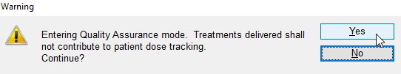

* 1. Highlight the first beam and click **Select**.

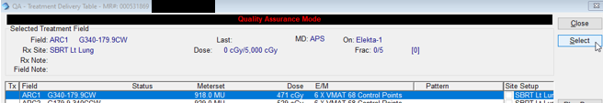

* 1. The **Manual Site Setup Verification** window will appear. Exit it.
  2. Click **Yes**.

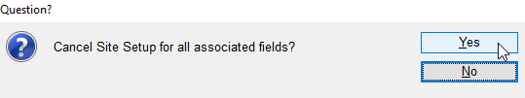

A window like the following will appear:

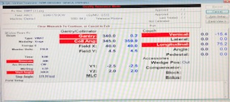

1. Set up the Delta4 phantom.
   1. Get the Delta4 phantom cart from the hot lab. The hot lab key is in the keys bag in the cabinet to the top right of Kthe physics assistant workstation. Unplug the phantom and put the charger in the emesis basin on the phantom cart. Get the yellow thermometer from the hot lab (OPTIONAL). Push the cart into the E1/E2 treatment room.
   2. If the therapists have anything on the table, scoot it to the end of the table.
   3. Push the phantom cart toward the table, and use the controls to raise the table so that the lip of the cart just overlaps the table. While holding down the large button on the bottom of the controls, push the Z switch up.

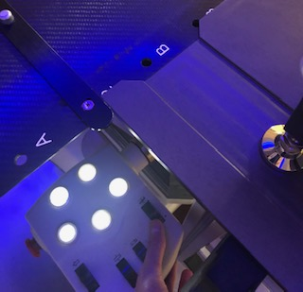

* 1. Gently push the phantom onto the table, exerting some vertical force.
  2. Plug the phantom into a wall outlet if it doesn’t have enough power to run DQA. You may need the extension cord that is in the emesis bin on the cart.
  3. Turn on the phantom. The Wi-Fi light should blink blue, but it is probably okay if it doesn’t or if it just blinks once.

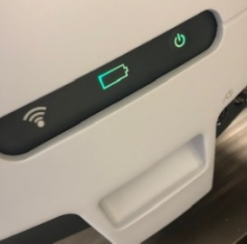

* 1. If the lasers are not on, press the **ISO CNTR** button on the hand pendant while holding down the side buttons.

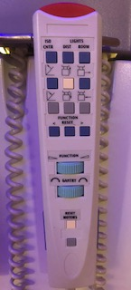

If you cannot see the lasers, turn off some lights.

* 1. Align the phantom with the lasers.

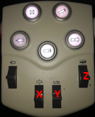

1. OPTIONAL: Use the yellow thermometer on the phantom cart to take the temperature on top of the phantom. Wait a couple of minutes for the temperature to stabilize.
2. Close the door to the treatment room.
3. In MOSAIQ, prep the beam to be shot.
   1. Hold down the indicated buttons on the Elekta console until nothing in the **Gantry/Collimator** column on the computer is red.

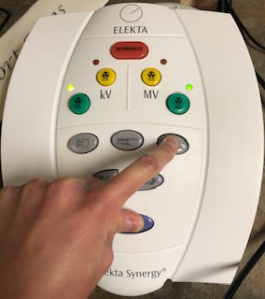

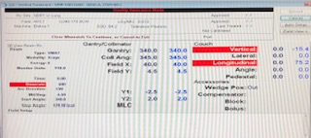

* 1. The only red fields should be **Doserate**, **Vertical**, and/or **Longitudinal**. Right click and select **Override**.

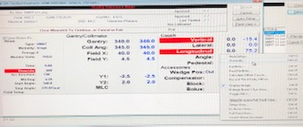

**Note:** If **Doserate** is red, remind Dosimetry to set dose rate to zero for VMAT beams.

* 1. Hit the space bar once for each field to override. Enter your password. 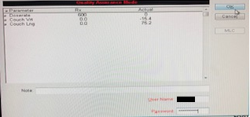

The following window should appear:

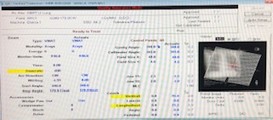

1. Shoot each field. See section “Collecting Dose” in procedure [Delta4 for DQA](Delta4%20for%20DQA.docx). Some Elekta-specific instructions:
   1. When the field view on Delta4 turns pink, press the MV button on the Elekta console.

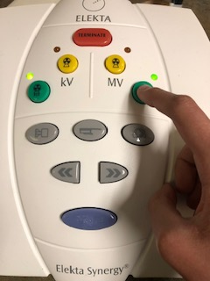

* 1. When the beam finishes, click **Record**.

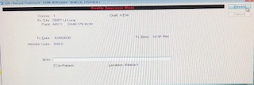

1. Unload the Delta4 phantom from the table. Turn off the phantom.
2. Return the Elekta treatment room to the way it was before you shot QA.
   1. Set the gantry to 0°.

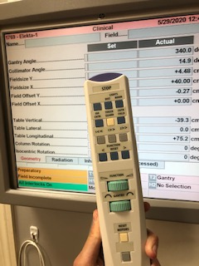

* 1. Restore the table setup.
  2. Fully unload the table.

1. Close out of MOSAIQ.
   1. Close out of the top window.

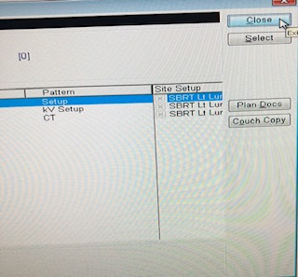

* 1. Confirm.

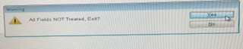

* 1. Close out of the next window.

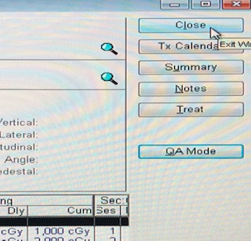

* 1. Log out.

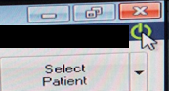

1. Optionally, leave a Post-It note on the monitor saying what time you finished running beam. After any extended period (such as lunch) without beam, the therapists must warm up the kV tube, so it’s nice to let them know if this is not necessary. Example Post-It text:

Finished running beam @ 12:35

* KW

1. Return the phantom to the hot lab. When you plug the phantom in, the battery light should be orange. Replace the thermometer on the bookshelf.

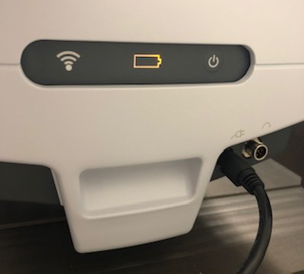

1. Carry the Delta4 computer back to Physics and plug back in the cables.
2. Evaluate the beam statistics. See section “Analyzing Dose” in procedure [Delta4 for DQA](Delta4%20for%20DQA.docx).
3. Print the Physics Report. See section “Printing a Report” in procedure [Delta4 for DQA](Delta4%20for%20DQA.docx).
4. Upload the Physics Report to MOSAIQ. See procedure [Upload DQA Physics Report to MOSAIQ](Upload%20DQA%20Physics%20Report%20to%20MOSAIQ.docx).